**AWS ACCOUNT SET-UP FOR TERRAFORM**

**Step 1:** Login to AWS Account

**Step 2:** Create an IAM User & Access Keys to it

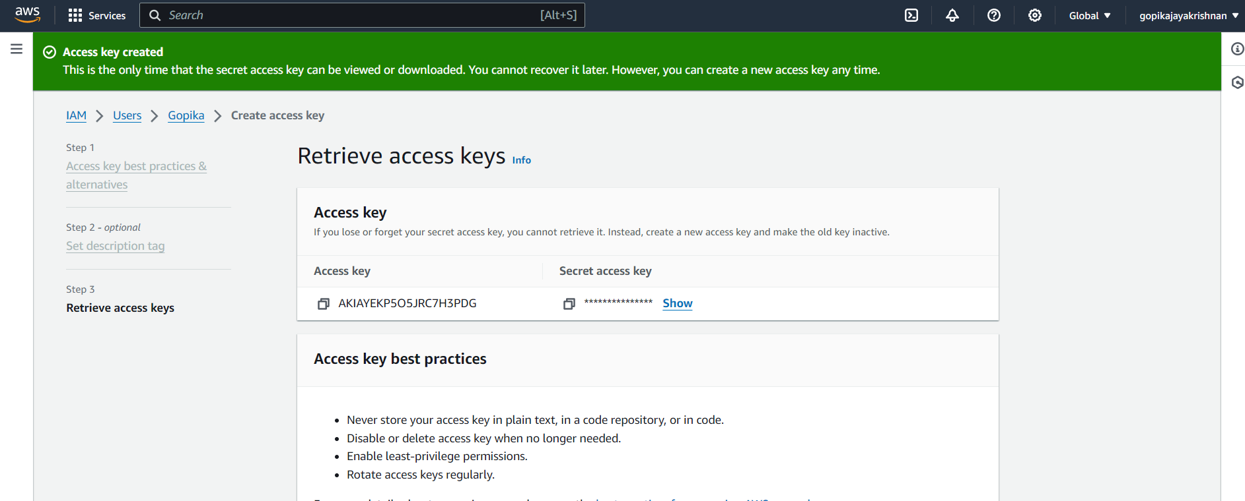

**Step 3:** Open aws cli cmd and Connect our aws account to it using comments

aws configure

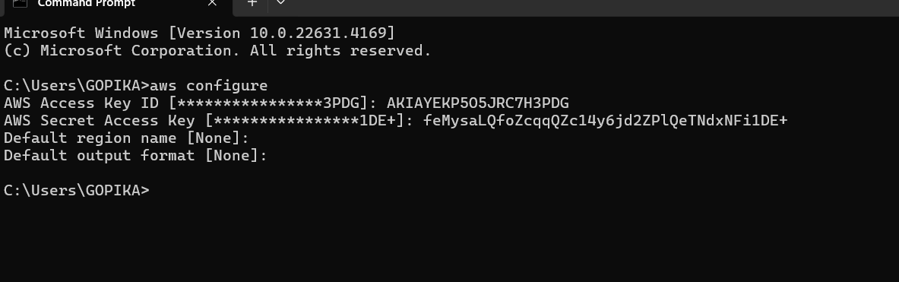

**Step 4:** Now create the terraform files needed for the usecase

Open cmd inside the terraform folder which has the code

Run terraform init

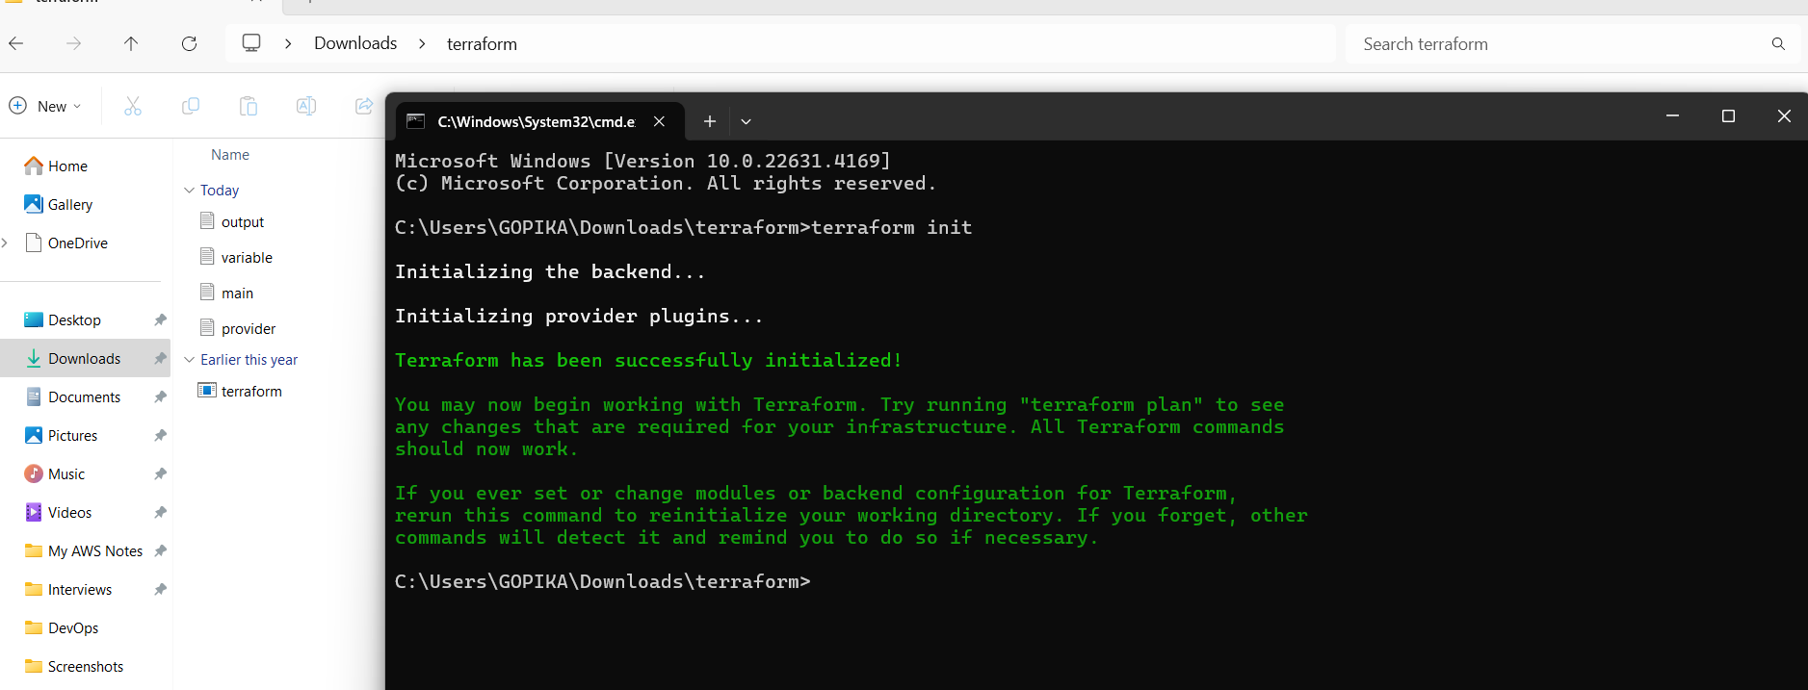

Run terraform plan

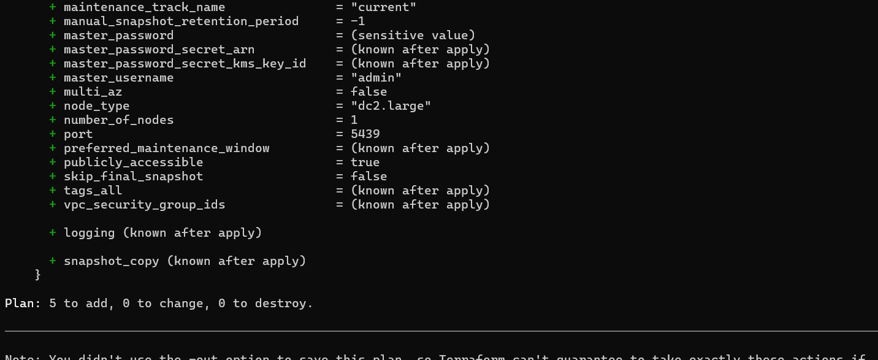

Run terraform apply

Now all the resouces are successfully created

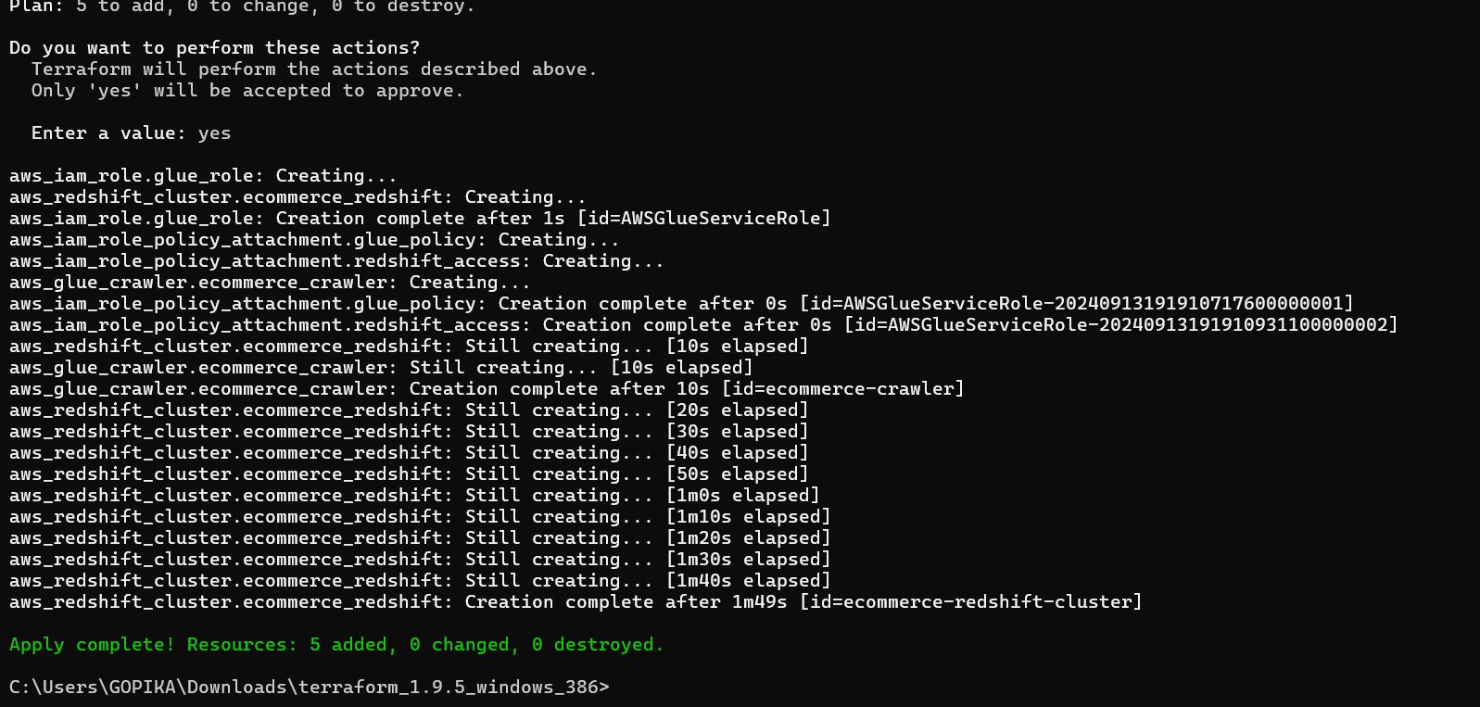

Run terraform output

**Checking Resources is created in AWS Account**

**S3 Bucket:**

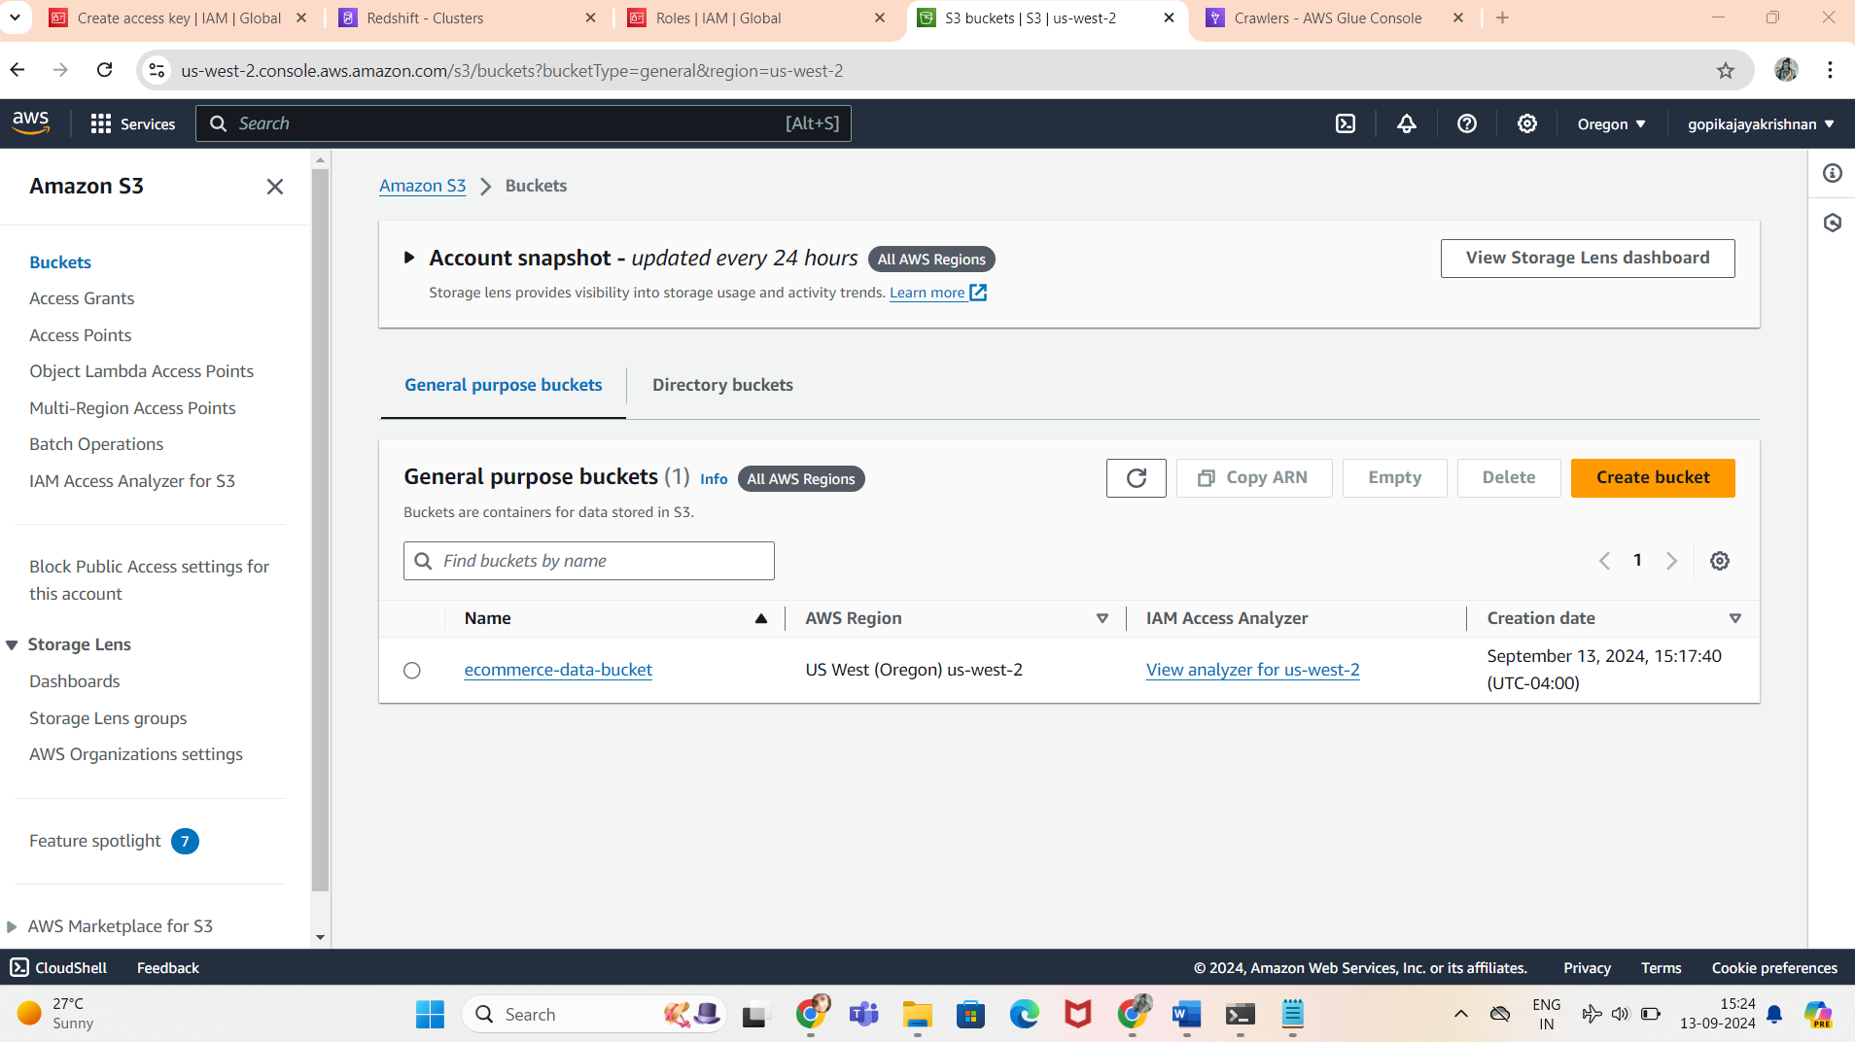

**AWS Glue**

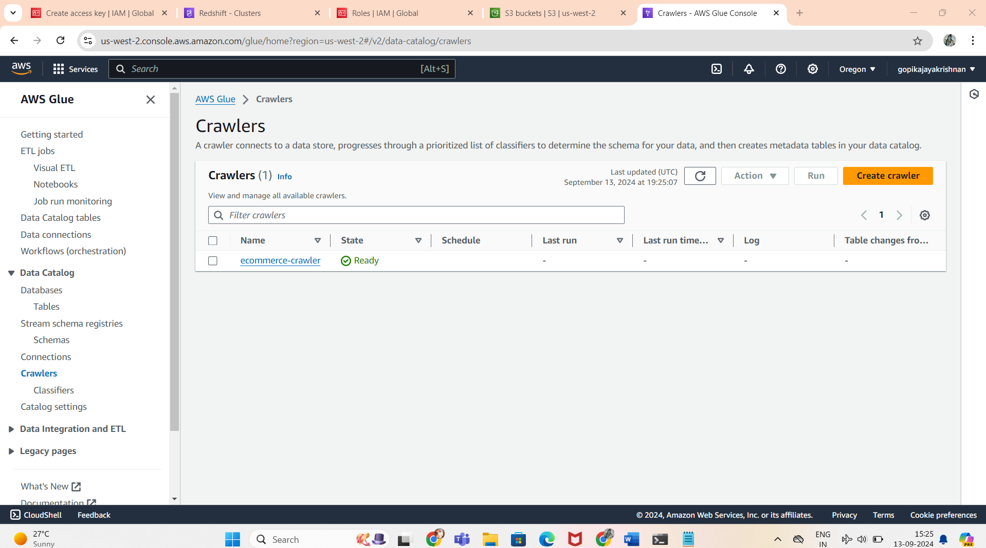

**Amazon Redshift**

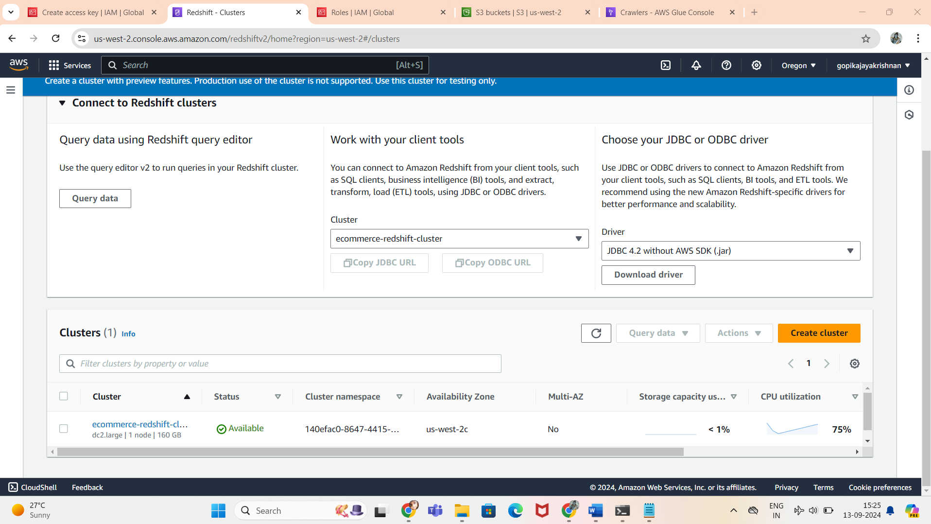

**IAM Roles**

